Frozen: The Cold Hard Truth about Hypothermia in Trauma
Janet Taylor BSN, CEN

There are several brand name products shown in this presentation. I am not an employee of anyone except for Mercy Hospital in Springfield. I don’t care what type of product you use to warm up a patient as long as it is safe for the patient.

There are actually some good things that occur when you induce hypothermia in some patients. But this is under very specific situations including

_______________________________, _________________________________________________, ______________________________________.

Hypothermia in trauma has always been ________________. Studies show up to 50% of trauma patients are hypothermic upon arrival to the ER. They are also 5 times more likely for deadly complications.

Case Western Reserve University School of Medicine released some studies showing that, “Injured patients with hypothermia are more likely to die than normothermic patients with a similar injury severity score”

When you have a trauma patient who is hypothermic you have
_________________________________, _________________________________, __________________________________________________.

The “Trauma Triad of Death” is a cycle that can occur at any point in the cycle and it feeds upon itself getting worse with every step.

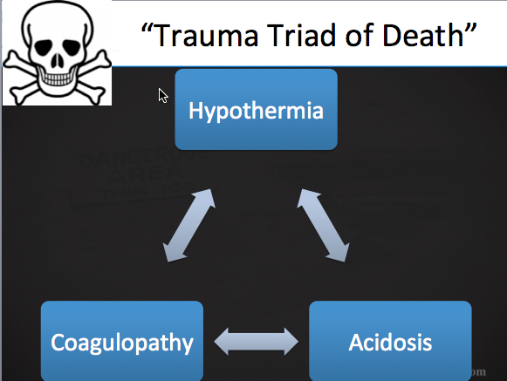

_______________________ Hypothermia occurs in trauma patients due to rescuers interventions. This is nearly completely preventable.

Mild hypothermia effects include vasoconstriction, _____________________________________________, increase ___________________________, and an increase in calorie demand.

When the body gets to a certain temperature below normal a condition called _______________________________
Occurs. This is when the brain senses a need to rid itself of excess fluids. Anti-diuretic hormone is decreased leading to large amounts of urine production. When this occurs, the patient is very hypovolemic. Keep this in mind when you begin warming them back up.

Cerebral blood flow decreases ____________ for every 2 degree F drop in temp.

Medications aren’t metabolized under cold conditions. If/When re-warming occurs, those medications that have built up in the body become a _______________________ to the heart.

Remember that “Trauma Triad of Death”? Here is how it goes down…….

______________________________ causes microclots. Microclots clog up the peripheral circulation. When this happens _______________________ don’t get perfused. This leads to _______________________________. And THIS leads to Coagulopathy. And repeat the whole process again.

So how do we compensate? What our bodies do in order to survive before rescue gets there is pretty cool (no pun intended)

The ___________________________ regulates our heat production in our body. It can sense a decrease in core temp of less than _______ degree. Our Sympathetic response kicks in and we get
______________________________________________________ (aka Goosebumps)
_____________________________________________________ (yes, this is real word)
Shivering….. …….

Shivering is the most ______________________________________ when measuring heat production calorie for calorie.

BUT… shivering is a form of strenuous exercise. It does create ______________________________________. If the kidneys are beginning to get cold then the acidosis cannot be reversed very efficiently.
When shivering stops, the body is no longer maintaining heat or even getting warmer, Heat loss is exponential when shivering ceases.

The 2nd Law of Thermodynamics sounds boring but we put it to use every day in our personal lives as well as in our profession. Basically the old rule says that HEAT will always travel to an area of lesser heat NEVER an area that is hotter than itself. Heat will continue to go towards the cooler area until both of the areas are the same temperature.

Hypothermia is defined as a core body temperature of less than 95 degrees. BUT in trauma patients this rule is actually _________ degrees. So we have an even smaller window of opportunity to get this patient treated.

When I mention taking a temperature, I mean a CORE temperature! Axillary doesn’t count, oral doesn’t count. Rectal is the only accurate way of taking a temperature.

Patients who have pre-disposing factors to developing hypothermia are

___________________, _____________________________, _____________________________________________, _______________________________, ____________________________________________, __________________________________________ and _________________________________________.

Environmental Factors that put a patient at risk of developing hypothermia are
______________________, ___________________________________, ________________________________________________, ___________________________, ____________________________________________.

I always say, “Tis better to be dry and naked and wet and clothed!”

So why do trauma patients specifically get cold?
EMS removes clothing for assessment (not a bad thing, it IS part of our job, right?)
Environment (scene times, wind, rain, snow, ice)
Backboards, splints (you ever felt a warm backboard?)
High flow 02
Medications that inhibit heat production (________________________________________________________________________)
ER staff pulls back blankets for exam, xrays, etc)
IV fluids that aren’t warmed.

Infusing ONE liter of room temperature fluids will ____________________________________________________.
Infusing ONE unit of PRBC (unwarmed) will ___________________________________________________________.

When we do re-warm these folks, we want to do it nice and slow. No faster than __________/hour.

__________________________________________ occurs when you begin warming the patient back up and their core temperature continues to drop a degree or two despite the warming.

“Avoid Rough Handling”. Any bump or jostle can cause a ripple effect to the circulation and cause a “wave” of cold blood to hit the heart.

_____________________________ wave is a specific condition that affects the hearts electrical conduction system. This can happen at any temp below 90 degrees but it isn’t a hard and fast rule. It is only seen in about 30% of hypothermic patients.

WARMING UP

Remove anything wet (remember that little Janet-ism I mentioned earlier?)
Put a blanket between pt and backboard
Apply additional blankets
Turn off the a/c or turn on the heat
Warm IV fluids and blood
Warmed 02 if you can get it.
Warm packs to armpits and groin.

Snuggling ____________________________________________________________________________________________________________.

Warm Sweet Drinks ________________________________________________________________________________________________.

Remember Cold Diuresis? Your patient is hypovolemic? What happens when you begin warming them back up? Venous Dilation! So the bottom line is your patient will be REALLY hypotensive. Warm fluid boluses are great but they have to be done carefully.

Aggressive Re-Warming isn’t seen in EMS but we do this stuff in the ER once in a while. Remember! No faster than 1-2 degrees per hour! This aggressive re-warming is usually a last ditch effort.

Gastric lavage
Bladder Lavage
Warm Enemas
Thoracic Lavage

